How To Create a Microsoft Account for SharePoint
- Open the email sent from Power. Click on the orange link ("Power Safety E-Forms")
*You can not use the SharePoint app; this must be done on a browser*
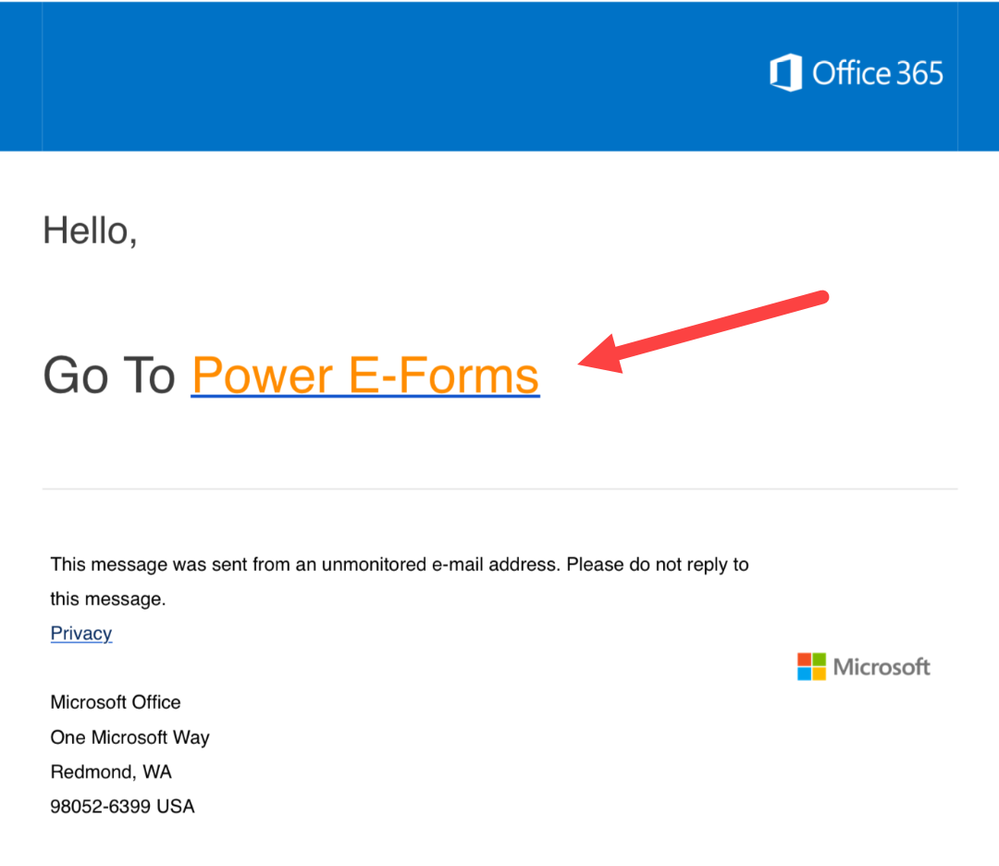
- This screen will appear:

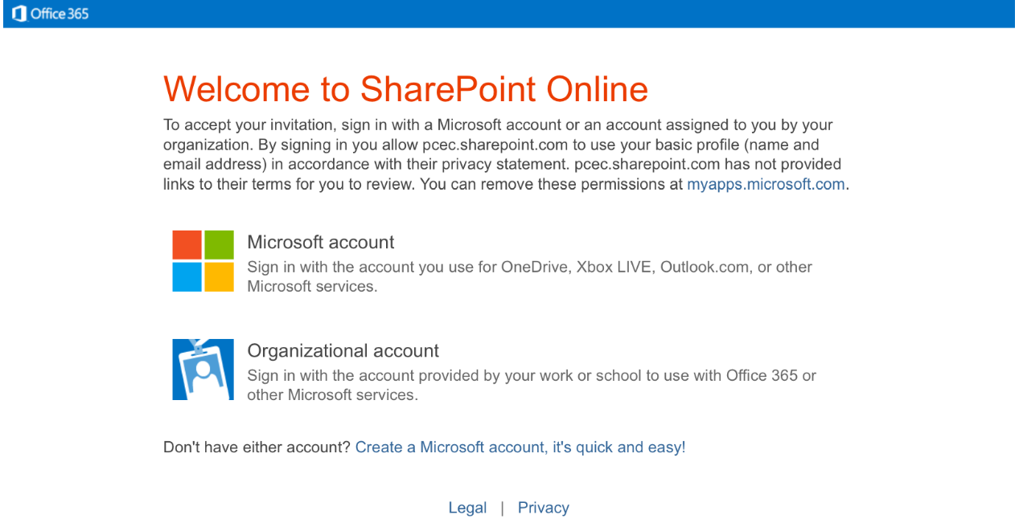
- If your company uses Microsoft, click on "Organizational Account" and log in using your company email and password.
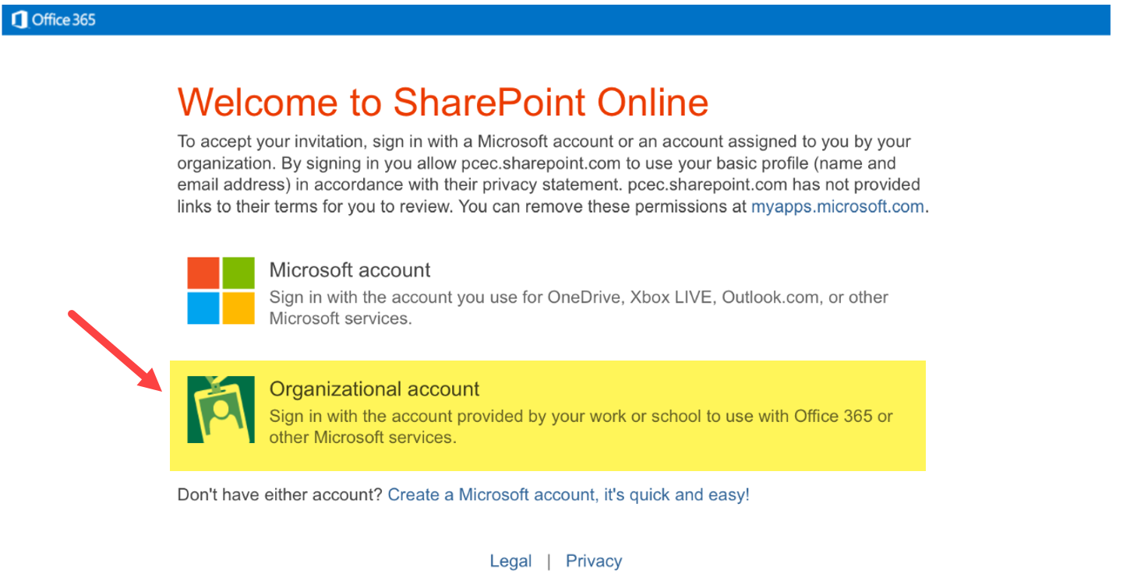
The log in screen looks like this:
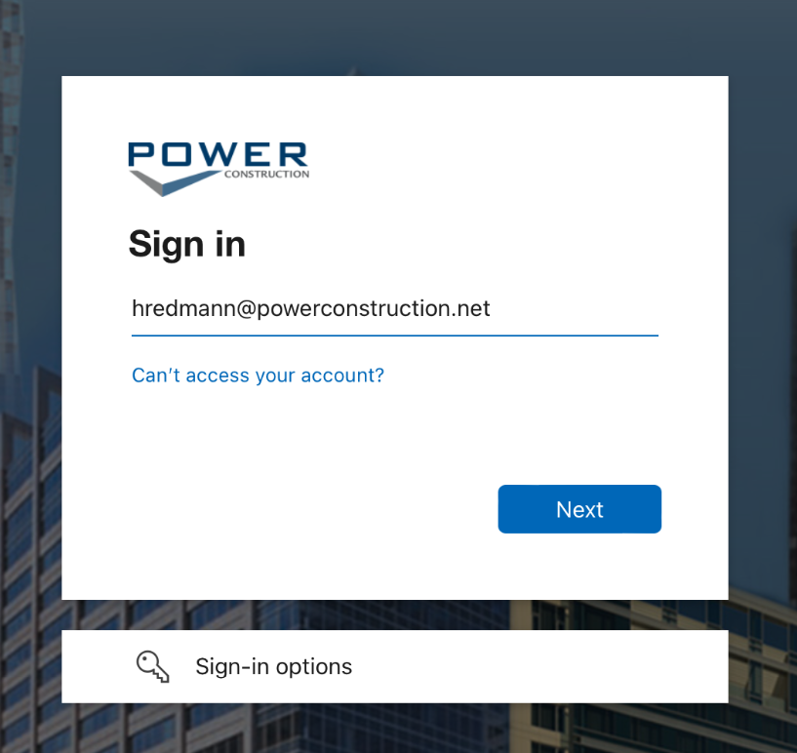
- If your company does not use Microsoft, click on "Create a Microsoft Account".
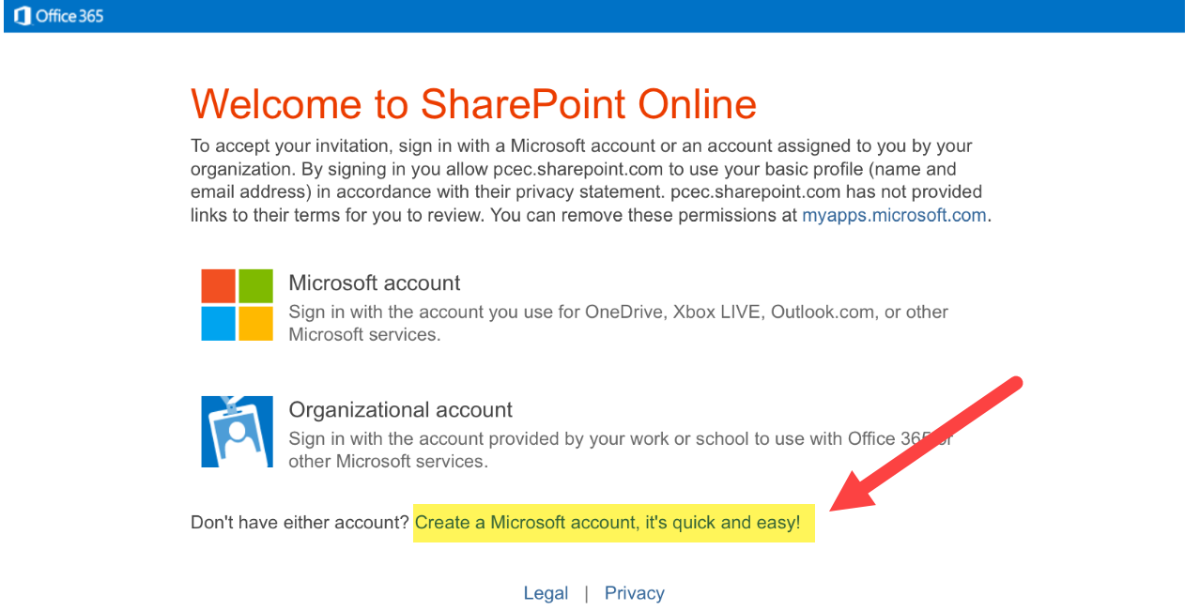
- Fill in the required information
- Use the email address that the invite was sent to
- Create password (case sensitive)
- Select "Next" at the bottom of the screen
- After your account has been created the page will look like this
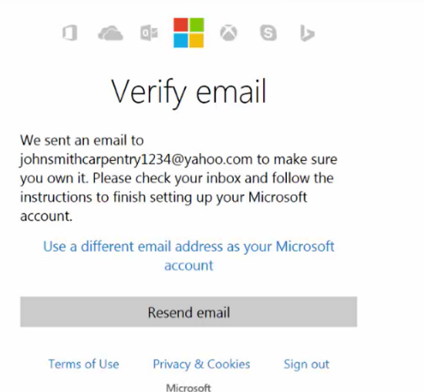

- Go back to your email inbox to complete verification
- Select the email titled "Verify your email address"
- Select "Verify your email address" highlighted in blue
- This screen will appear
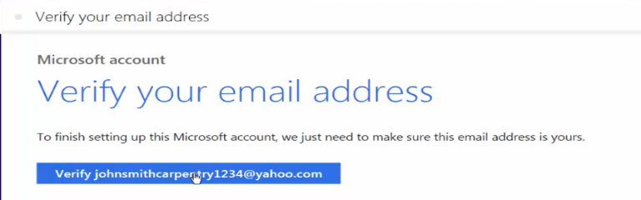

- Return to your inbox and Select "Power Safety E-Forms" link
- You now have access to SharePoint

